IELTS Writing Task 1 Table

The tables show results of 2 surveys done in 1980 and 2010 on various aspects of city living in a particular city. Units are measured in percentage.
Summarise the information by selecting and reporting the main features, and make comparisons where relevant.

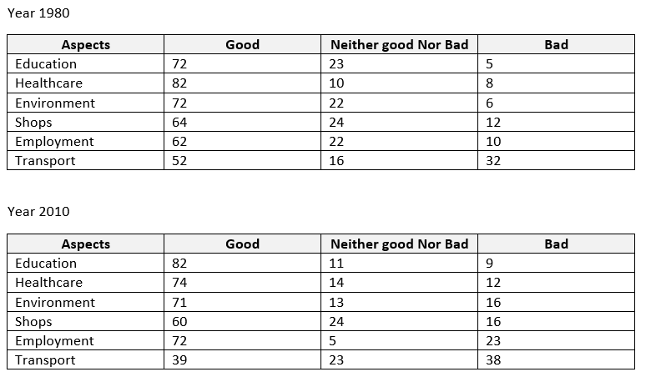

The above table is a reproduction from various students who reported this table in their IELTS test in October 2017. Data may vary from the original.
This is a more complex table than usual. Most IELTS tables are not quite so challenging.
A model answer can be found for this writing task 1 @ www.ieltsliz.com

